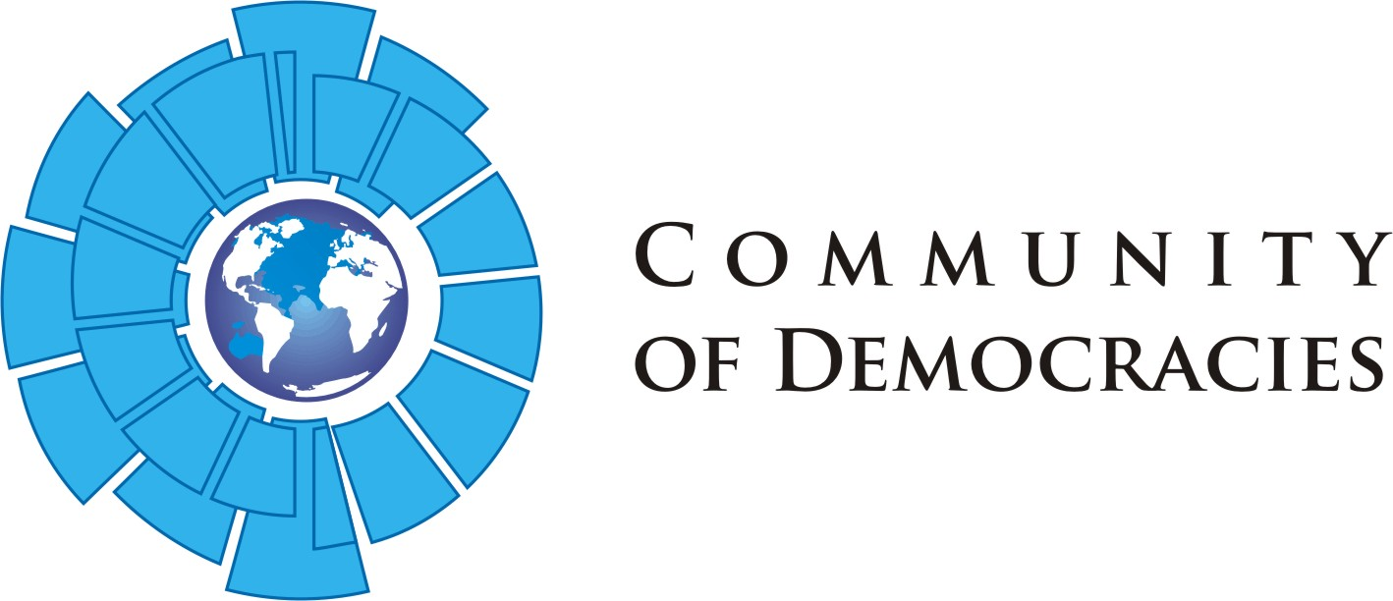

Identifying, Collecting, Organizing, and Publicizing
Democracy Education Materials
Application form

Please be certain you have reviewed all information in the application guidelines before completing this form.

Full name of applying institution or organization:
Legal status:
Address:
Website:
Contact person responsible for the application:
Email:
Phone:
Name of alternate contact:
Email:
Phone:

Please address the following points. You can write in bullet points if you wish.
- Organizational capacity and past performance of the institution or organization (approx. 200 words, max. 25 points)
- List of resources and topics that will be posted (approx. 200 words, max. 25 points)
- Technical aspects of the project (approx. 200 words, max. 20 points)
- Brief schedule of the project (approx. 200 words, max. 20 points)
- Budget. Please provide approximate costs for the project according to the following categories. Please note that the grant maximum is US$45,000. A more detailed budget will be requested during the second stage of the application process. (10 points)
  - Personnel (project coordinator, content, technical, graphic design, website design, translators, etc.): _________
  - External consultants: _________
  - Equipment and supplies (including IT, software applications): _________
  - Other (copyrights, publicity): ___________

Please send your completed application by 15 December 2014 to: democracyeducation@community-democracies.org

