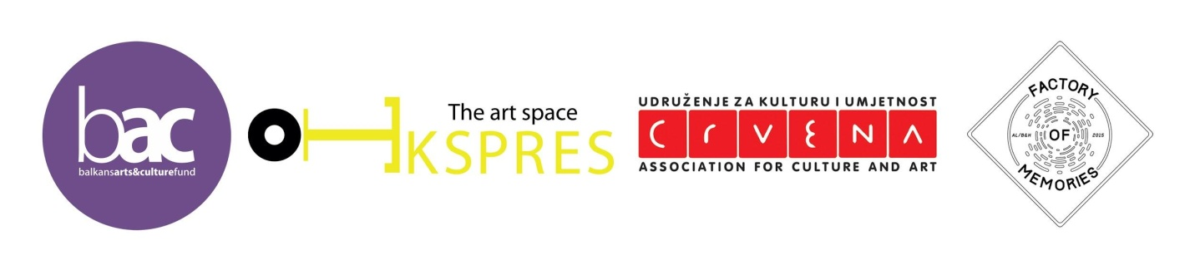
APPLICATION FORM 2015
“Factory of Memories”
Collaborative project of Tirana Ekspres and Association for Culture and Art CRVENA

First Name/ Last Name:
Date of birth:
City and country of birth:
Nationality:
Current address:
Phone Number:
Email Address:
Website/blog:
LANGUAGE SKILLS
*Basic English is required. Grade from 1 to 5.
Understanding | Speaking | Reading | Writing
 |  |  |  | English
 |  |  |  | Other languages
COMPUTER SKILLS
*Basic OS (Mac/PC) working knowledge is required.
Please list audio/video softwares you have experience working with, and rate them.
Basic | Good | Excellent
 |  |  | 1.
 |  |  | 2.
 |  |  | 3.

Add more rows if needed
SPECIAL REQUESTS/NEEDS
Special diet
Other
1. CV (max:500 words)
2. Have you had any experience that relates to the topic of this project? Please elaborate. (max:300 words)
3. What is your motivation for wanting to take part in this project? (max:300)

