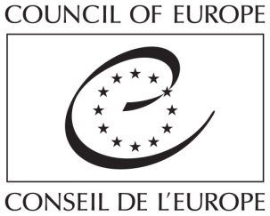

EYF (Re)mix

1-4 March 2016
European Youth Centre Strasbourg, France

Application form for participants

(To be sent to eyf@coe.int by 10 January 2016)

Organisation’s information:

Name of the organisation

Name of the organisation in English

Abbreviation/acronym

EYF registration number

Person responsible

Address

City

Country

Phone

E-mail address

Website

The organisation proposes the following applicant:

Applicant’s information:

First name applicant

Family name applicant

Date of birth

Gender

City

Country

E-mail address

Personal phone/mobile where you can be reached if necessary

Blog, website or webpage (if any)

Applicants must reply to the following questions (maximum 10 lines per question):

- What kind of work is your organisation doing and in which area?

- What experience does your international or local NGO have with activities supported or not by EYF? (In case of granted projects, please mention the reference of the grant.)

- What is your personal experience (minimum 2 years) in running projects funded or not by EYF? (We would like to know which project tasks you were responsible for and challenges/successes you encountered.)

- What would be useful for you and for your organisation to learn during this meeting?

- Did your organisation participate in one of the previous EYF seminars: (Re)loaded in 2013, (R)evolution in 2014, (Re)generation in 2015? If yes, how did your organisation benefit from participating in that meeting?

- With the introduction of the grant categories of work plans and pilot activities we would be curious to receive some feedback from your side as this will help us to shape the programme of the meeting. What is your personal experience with these grant categories: what positive elements did you identify, which challenges did you face and what are the open questions you still have?

