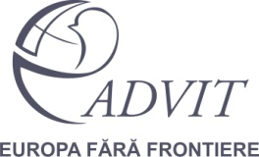
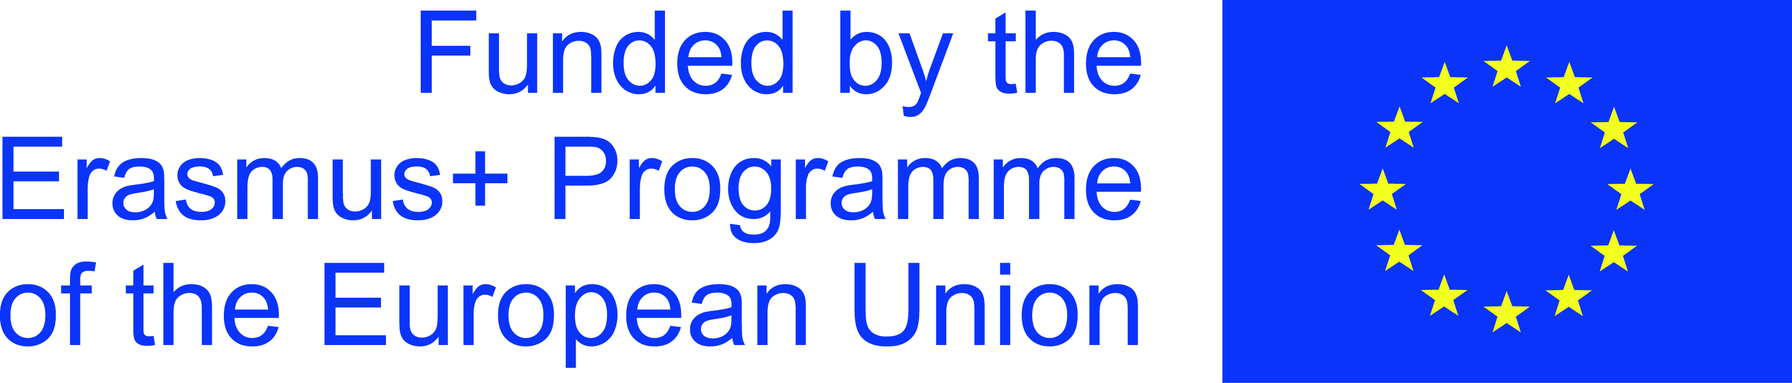

International Training Course “Dissemination and Exploitation of Project Results by Social Media”
01 – 09 September 2016, Vadul lui Voda, Moldova
REGISTRATION FORM
To be filled by 30th June 2016 and send to codec.europe@gmail.com
FAMILY NAME
FIRST NAME(S)
GENDER
DATE OF BIRTH (DD/MM/YEAR)
NATIONALITY
ORGANISATION YOU REPRESENT

POSITION HELD IN ORGANISATION

ADDRESS

TOWN & ZIP CODE
COUNTRY OF RESIDENCE
TELEPHONE
EMERGENCY CONTACT(S)
E-MAIL
PASSPORT No. /date of issue and expiry
Please underline or mark with another color your English level | FLUENT // GOOD // INTERMEDIATE// BEGGINER
Please briefly explain your previous experience in youth work (max 5 lines)
Please briefly explain your experience in training topic (max 3 lines)

Please underline or mark with another color the social networks your organization mainly uses for project results dissemination | Facebook // Twitter // Website of your organization // Youth portals or other networking channels // Others
Do you personally use social networks? (please list those you use and how often)

What is your motivation to participate in the training course (max 5 lines)

What are your expectations towards the training course? (max 5 lines)

Estimated date and time of arrival (DD/MM)
Estimated date and time of departure (DD/MM)
Expected travel costs and means of travel (plain, train, bus)
Any comments you would like to share

SPECIAL NEEDS (vegetarian, no pork, allergies, other diet)

