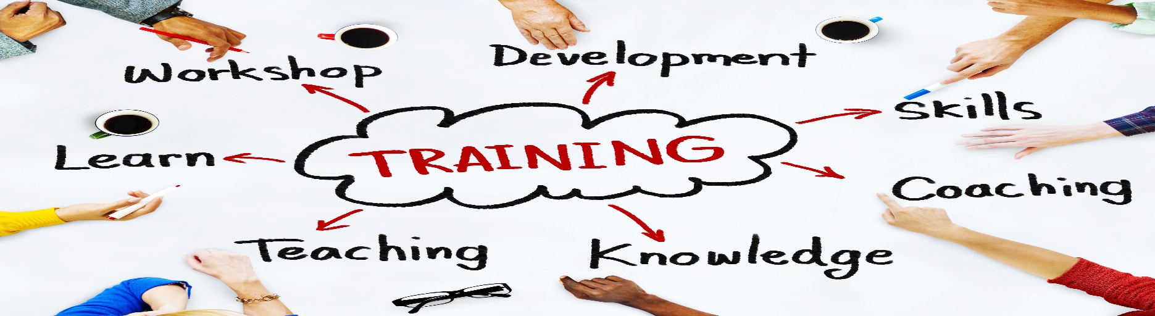

INFO PACK for Participants

Training Course:
”Teaching methods in interculturally mixed areas”

In: Prague, Czech Republic
22-30 October 2016

Summary of the project:
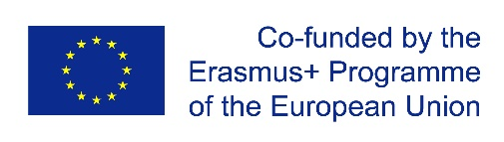
We are living at a time when more people than ever living outside their home country. 3.2 per cent of the world’s population live outside their country of origin. Through the years around 72 million migrants have made their home in Europe. Just EU is home to over 33 million people born outside the EU. In addition, there are more than 17 million citizens switched their country of birth within the EU. Nowadays conflicts at the Middle East are forcing more refugees to seek safety in the EU. Like it or not, the European societies are ethnically and culturally mixed, and the trend is growing. But as societies are becoming more mixed, the conflicts between the people from different nationality, religion, race, background and etc. are increasing. This situation is increasing the demand for extra methods, skills and tools which will be put into practice in order to improve the communication and cooperation for peacefully living together. And if people have positive and enriching experiences with other cultures than they are more likely to embrace diversity.
The idea of this training was driven from that fact, to bring various methods and tools which the youth workers and teachers from interculturally mixed areas can effectively use.
Methodology: The training will be build up on participatory based approach where the participants will have a chance during the whole training to experience various teaching methods and approaches. In the last days they will have a space for individual skills simulation which will lead to improvement of their interactive skills.
The general aim is: To Increase the knowledge and understanding about Intercultural communication and cooperation, and bring various teaching methods for transferring that knowledge to the societies.

Profile of the participants

- People who are interested in the topic and have previous experience in teaching.
- Age: from 18 and without upper age limit
- English is our work language, so it will be recommended at least basic understanding.
- Motivated, nice, cheerful, smiling participants in a good mood ready to learn from each- others, cooperate and share the positive European values further in their communities for more inclusive societies!
- Erasmus + is a programme which supports disadvantaged young people, so this project open for young people with fewer opportunities. The accommodation is adapted also to people with special needs,

Cost and Conditions of the Participants:

Training course is financed by Erasmus+ Programme, so grant covers 100 % of activity cost (venue, food, and programme) and 100% of travel costs. Reimbursement of 100% of travel costs will be done on a basis of original tickets, invoices and boarding passes after the training course.

Youth Pass Certificate

Each participant will receive YouthPass, which:
- Certificate of non-formal education (you will take part on an educational activity)
- You can include it in your CV and use it for school, university, new job, etc.
In the beginning of the project we will divide participants into a small groups that later will work every evening in the reflection groups where they'll talk about the day, activities, what they have learned, etc. With all these notes, at the end of the training course will be a workshop where the participants will work in their own YouthPass. YouthPass will be reached at the end of training course.

Before training preparation

Before your arriving to Czech Republic we can advise you some things for preparation which will be useful here, and also will help lead some activities:
1. A presentation of your NGO and what is you looking for;
2. Collect information about teaching methods in your home country;
3. For presentation of intercultural evening please prepare and bring with you: music, traditional food, dances, games, pictures etc;
4. Good mood and inspiration!
Daily Schedule
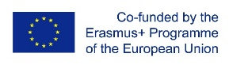
22.10 | 23.10 | 24.10 | 25.10 | 26.10 | 27.10 | 28.10 | 29.10 | 30.10
A  R  R  I  V  A  L  S | Ice Breaking activities & Name games | Active listening and interpretation,  Babel tower activity | Interpretation and evaluation exercise (what I see, what I think, what I feel) | Developmental model of intercultural sensitivity (Bennett model) | How to set up productive environment for teaching and learning | Free time for planning future projects | How to give structural feedback | Project evaluation  D  E  P  A  R  T  U  R  E  S
 | Getting to know each other more personally (Expectation, motivation and fears) | Experiencing non verbal and verbal styles of communication. | Speed dating about culture,  Web of culture | Cohesion in multicultural teams | Teaching and learning styles | Presenting projects | Skills simulation
 | Lunch | Lunch | Lunch | Lunch | Lunch | Lunch | Lunch
 | Work on computer: how to work on google drive and write on blog | “Albatross culture'' game | Iceberg model of culture | Cultural identity model (from Larke Huang ) | Erasmus+ programme possibilities | Presenting projects | Continuing skills simulation
 | Creating reflection groups | Workshop for stereotypes and prejudices | Exploring the mindset of the host culture | Reflection group will evaluate the day and rate the activities | Creating project structure and setting objectives | Individual skills simulation planning | Continuing skills simulation
Dinner | Dinner | Dinner | Dinner in the city | Dinner | Dinner | Dinner | Dinner
Introduction  and team building games | Get to know each other | Reflection group will meeting for evaluation | Reflection group will evaluate the day and rate the activities | Cultural exchange night | Reflection group will evaluate the day and rate the activities. | Individual skills simulation planning | Firewall evening

Venue

We will provide information about the exact venue and hotel soon! It will be in beautiful Prague!
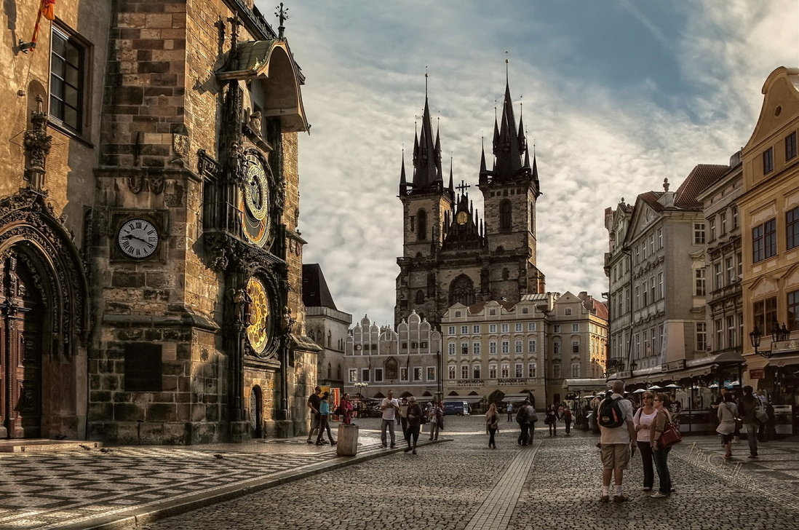
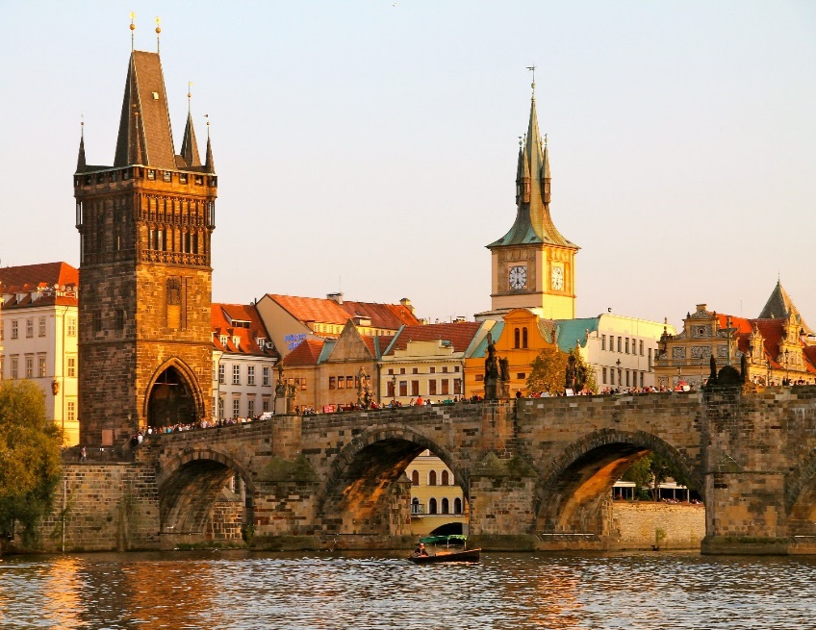

Contact:

Contact person: Mariia Yatskovska
Phone number: +420 731129155, +420 799798604
E-mail: mariiayatskovska@gmail.com

