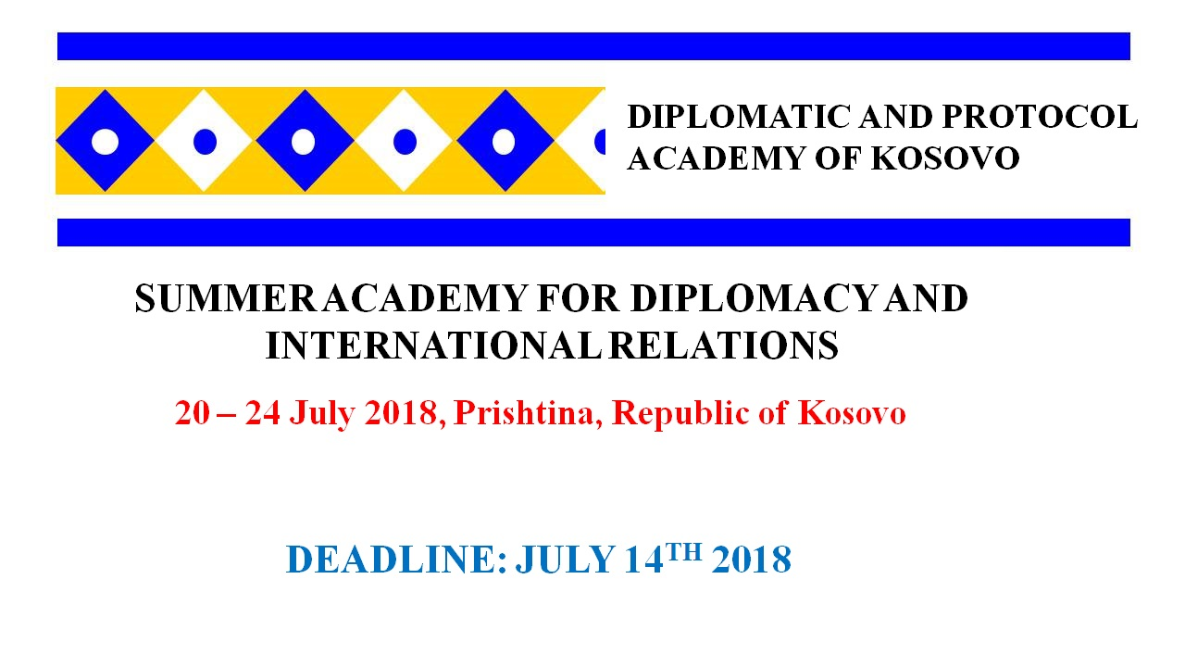Invitation to the “Summer Academy for Diplomacy and International Relations” 20 – 24 July 2018, Prishtina, Republic of Kosovo
The Academy for Protocol and Diplomacy, have a great pleasure to invite you to
Participate at this Edition of “Summer Academy for Diplomacy and Diplomatic Protocol which will be held in Prishtina, Kosovo, and also participants will have a chance and a pleasure to visit different places of Prishtina such as: New Born Monument, National Library, Ethnological Museum and Mother Theresa Square.
#CourseDescription:
The overall aim of this course will be to introduce students to the art of diplomacy in the Western tradition with an emphasis on the beginning of the 19th century through to contemporary international politics. In particular, the course will stress the evolution of the role of diplomacy, diplomatic communication, preventive diplomacy and coercive diplomacy over time and how such factors as technology, communications and ideology have impacted the efficacy of the diplomatic process. Students will be shown the relationship of diplomacy to the political system, especially how the ambassador's role is rooted in constitutions and international norms. The course will provide a clear account of the shape and functions of the world diplomatic system as it stands at the beginning of the 21st century: what it is, what it does, and why it is important. The course aims to provide knowledge of the nature of diplomacy; when diplomacy is appropriate; the advantages and disadvantages of different diplomatic methods; and the lexicon of diplomacy. Students will be given a strong grasp of the nature of diplomacy conceived as a specialized professional activity developed over many centuries, and be able to defend its value with authority and enthusiasm.
#Readings and Assignments
The course will not have a final exam. Instead, students will be expected to raise a series of short papers/topics throughout the sessions, engage in two in-class debate and participation activities and submit a final paper.
The final paper shall be an examination of one particular diplomat and a crisis that he or she dealt with. More information shall be given in class.
#DraftAGENDA
Arrival and registration of participants
What is diplomacy and International Relations?
Diplomatic Communications and diplomatic hierarchy
Diplomatic correspondence, presenting diplomatic samples
Group exercise (write a diplomatic paper)
Preventive Diplomacy and Conflict Prevention: Obstacles and Opportunities
Coercive diplomacy, a case of Kosovo Conflict and Cuban Missile Crises
Diplomatic Protocol and Diplomatic Ranks
Group exercise (Kosovo – Serbian Negotiation process), participants will be divided in groups and
Present their positions, using all materials presented in “conflict exercise case “and
Diplomatic means presented in the course.
Visit to Ministry of Foreign Affairs of Kosovo
Visit to National Parliament of Kosovo
Cultural Visits to Gadime Cave, City of Prizren, Ethnological Museum of Prizren League, Kosovo
Closing up ceremony, certifications and family picture
#TargetGroup
Students with different academic backgrounds and a general interest in negotiation, diplomacy, diplomatic correspondence and international relations will benefit from each other in an intercultural and interdisciplinary learning process. Former classes consisted of regular students and practitioners such as civil servants, communication experts, EU Institutions employee, young politicians and even parliamentary officials.
The course does not require special knowledge about international relations, diplomacy, international negotiations, history or culture, but participants should be interested in more than just their field of specialization. In class participation, especially in the discussions with experts, is essential for the course success and plays an important role in grading.
#previous groups
Our previous groups contains participants from: UN international staff, EUCFSP staff, representatives from European governments, military officers, civil society officers, young professionals, students from BA MA and PhD levels from all over the world.
Lectures, presentations and examinations will be held in English.
Application for participation:
All participants must send their CV and motivation letter to prot.diplo.academy@gmail.com by July 14th , 2018, at 24:00.
Eligible country to apply:
The eligible students to apply are all students/candidates that no need visa to enter to the Republic of Kosovo
#TuitionFee:
Tuition fee for Kosovo student/participants is 78 euro;
The tuition fee for non non-Kosovo students/participants is 100 euro
#Accommodation for non Kosovo participants:
Our team can assist to find best accommodation in Prishtina, with cheapest price, up to 15 euro per night in private apartments in down town of Prishtina!!
#Tuition fee includes:
Tuition fee for Students covers:
Three lunches, Reading materials, lectures, coffee breaks, certification, study visits
#Scholarships:
ADP is happy to provide two full scholarships. The scholarship will cover: Three lunches, Reading materials, lectures, coffee breaks, certification, study visits
For more information and registration please contact us;
APD Team,
E-mail: prot.diplo.academy@gmail.com
Tel: +37745603619
+38649580344
FB page: Academy for Protocol and Diplomacy

