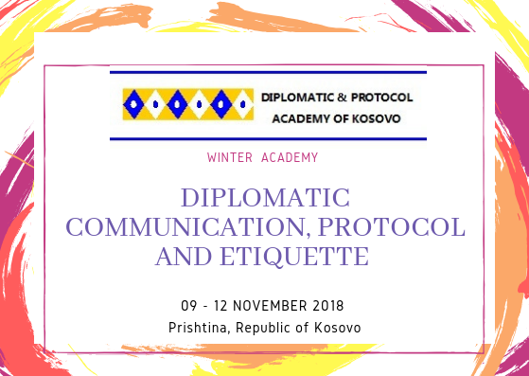

Academy Diplomatic Communication Protocol and Etiquette
09 – 12 November 2018, Prishtina Kosovo
#Academy for #Protocol and #Diplomacy has the immense pleasure of inviting you to participate in the event: Higher intensive course of diplomatic protocol and etiquette. This course of diplomatic protocol and etiquette offered by #best #experts of the fields from the region, provides a unique opportunity for university and college students, young professionals and young leaders to study the history, role, structure, competences and activities of protocol, as well as the military, political – security, and economic issues facing the defense diplomacy of new countries. Through these simulations-practices, students gain a better and clearer understanding of the capabilities and constraints that shape the policies of protocol in determining matters of Mutual understandings and best diplomatic, business and security relations among partners. Apart from dealing with a prepared agenda, students grapple with a contemporary crisis to be revealed at the Model.
Each participations, students or young professional will be able to be a trustful advisor for protocol. Upon the registration, participants shall receive preparatory material, which include the Agenda, Handbook and other publications.
Main goal of #Master Course of Diplomatic Protocol and Etiquette:
The main aim of the course is to gather young leaders from different countries to become familiar with the rules of diplomacy, it’s role especially to new countries, familiarity with the rules of the Protocol military and diplomatic, that in the near future, when they become decision makers and elected /appointed in leadership positions they have the culture of communication based interstate, international, inter-religious and intercultural high standards of protocol behavior.
Besides the main goal, the course has these objectives:
• To enrich students / young professionals, future leaders with general knowledge of the NATO defense diplomacy policies;
• To increase knowledge about the risks and challenges of the new diplomatic protocol, theories and practices in multilateral and multidimensional relations
• To qualify participants for the planning, organizing and implementing national and international activities in the field of protocol.
This activity will take place in Prishtina, Kosovo.
#TargetGroup
a. Students with different academic backgrounds and a general interest in security and Euro – Atlantic integration;
b. Young professionals interested to develop their intercultural and interdisciplinary learning process;
c. Civil servants, mass communication experts, young politicians and even parliamentary officials who want to further their knowledge of the protocol processes;
#Application for #participation:
All interested participants interested to take part in this simulation, must send their CVs and Motivation Letter to: prot.diplo.academy@gmail.com, +37745603619 by 5th November, 2018, at 23:59h.
#Participants #eligible to #apply:
All participants or candidates that #NEED #NO #VISA TO #ENTER to the Republic of Kosovo are eligible to apply at: Master Course of Diplomatic Protocol and Etiquette
#Contribution FEE:
The tuition fee differs from where are you from. Therefore, the tuition fees are as follow:
• Tuition fee for Kosovo Students is: 35 Euro
• Tuition fee for non Kosovo Students is 42 Euro
* All costs regarding the bank transfer of the participation fees so called transfer fees, have to be covered by the interested applicants / participants.
#These #tuition #fees will include:
- For the participants, lectures, workshops, materials and social events, including cultural tour around Kosovo;

#Scholarships:
ADP is happy to provide two full scholarships. The scholarship will cover: Accommodation Reading materials, lectures, coffee breaks, certification, study visits

#Accommodation:
ADP will provide three scholarships for participants, and will cover for non Kosovo participants, others accommodation can ask for support by the organization to book a reasonable price 15 euro per night!

