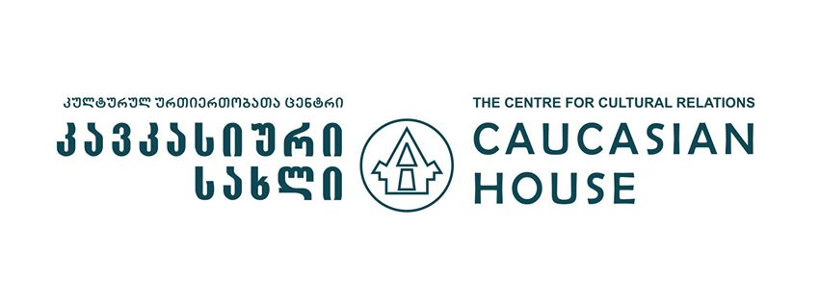

Regional Cooperation for Peace and Stability

APPLICATION FORM

Project description

The Centre for Cultural Relations — Caucasian House, with the financial support of the British Foreign and Commonwealth Office will be conducting a study and dialogue visit (4–12 February 2014) in Georgia. Project aims to promote the regional cooperation between young professionals (civil activists, researchers, analysts, academics, etc.) of the South Caucasus and Turkey in an effort to contribute to integration process between the respective societies. It is our hope that the project will help to foster peace and stability in the region while making a contribution to the integration of these societies. The process will consist of two components:

Study component: Participants will have the opportunity to receive information on current domestic and foreign policy issues in Georgia, examine the situation of ethnic and religious minorities in the country as well as look at the issues connected to economic development and security through meetings with senior officials, representatives of nongovernmental organizations, and think tanks working in the field.

Dialogue component: Participants will discuss the important issues in the region and in their respective countries. They will deliver presentations based on drafts submitted beforehand on prominent issues in their societies and discuss the possibilities for regional cooperation while working in the group. The presentations and discussions will form the basis for final articles which will be published on the website regional-dialogue.com. The website was developed under the dialogue projects previously implemented by the Caucasian House and serves as an analytical platform for the dialogue among young professionals from the region.

All costs related to transportation, accommodation, and board will be covered by the project.

Application process

The application form, CV or résumé, and the optional writing sample should be sent to regionalcooperation.ch@gmail.com no later than 12 January 2014, at midnight (UTC +04:00). Shortlisted applicants will be invited to an interview and notified of the selection results by 24 January.
Eligibility

◊ Residents of Armenia, Azerbaijan, Georgia, or Turkey;
◊ Age 23–35;
◊ University degree;
◊ At least early stage of professional/academic career;
◊ Interest in the region of Armenia, Azerbaijan, Georgia, and Turkey;
◊ Proficiency in English.

Selected participants will be required to prepare a draft article. It will be presented during the dialogue and study visit and will form the basis of the final article.

Name:
Click here to enter text.

Date of birth:
Click here to enter text.

Gender:
Male ☐ Female ☐

Contact information
Address: Click here to enter text.
Mobile phone: Click here to enter text.
Email: Click here to enter text.

Citizenship:
Click here to enter text.

Country of residence:
Click here to enter text.

Education:
Click here to enter text.

Occupation:
Click here to enter text.

Work experience:
Click here to enter text.

Why are you interested in participating in the project? (max. 150 words)
Click here to enter text.

What are your expectations for the project? (max. 150 words)
Click here to enter text.

What are the prospects for regional cooperation between Armenia, Azerbaijan, Georgia, and Turkey? (max. 150 words)
Click here to enter text.

How will the experience gained through the project benefit your future career goals? (max. 150 words)
Click here to enter text.

References: (contact details of two people)
1. Click here to enter text.
2. Click here to enter text.

Please attach your CV or résumé as a separate document.

Please attach a writing sample in English as a separate document. (optional)

