You are cordially invited to the seminar on

“Interesting Practices in Involvement of Youth at Risk into Hobby Education”, Tallinn, Estonia, November 10th –12th 2014”

The aim of the seminar is to support and encourage participants to develop and broaden their capacities of involving youth at risk in youth work, particularly in hobby education (leisure time activities/interest based education: where young people engage in adult facilitated music, arts, theatre, film, dance, sports etc on their free time).

As the main objective of the seminar we wish to support exchange and understanding of interesting practices across different contexts incl. different European countries.

You will find the seminar appealing if you appreciate:
· a constructive collegial learning and networking environment
· elaboration on the real-life cases from the group
· a good blend of non-formal and formal learning

The seminar will serve both:
· as an inspirational setting via presentations of real life example cases in Estonia, Hungary, Austria, former Yugoslav Republic of Macedonia, Belgium, Czech Republic and Iceland.
· and as a peer think tank thanks to the interactive and analytical format of the seminar

Participants are therefore invited to prepare and present real life example(s) that are used to enhance the involvement of youth at risk in hobby education. Your real life case could inspire and/or benefit from group wisdom and be anything from a bold success story to a struggle you need help in resolving. Please see attached guidelines for the presentations.

After presentations we will elaborate in depth about the presented practices and if needed, generate solutions! A list of success factors and eventually insightful patterns with conclusions will emerge. There will be time for both personal and country group reflection, recreation and fun as well.

Program start: in the morning of November 10th 2014. Please see draft agenda attached to the invitation. The three days are planned as full working days so arrival of the participants is expected on the 9th and return on the 13th. We will prepare a non-formal get-to-know each other evening on the 9^{th.}

The expected fruits/outcomes of the seminar:
· you will be informed about different contexts of youth work across participating countries, and especially the implications of those contexts for the involvement of youth at risk to hobby education
· you will be (re)thinking about your work in the light of the gained knowledge from the seminar, particularly about the dimension of involvement of youth at risk
· you will reflect about the opportunities to integrate the gained insights to your field
· you will feel stimulated by the distinguished success factors and you will be informed about possible pitfalls to avoid
· you will have concrete ideas on how to implement and multiply possible new ideas/tools/methods when you get back home.
·and you will have noticed your relevant learning needs and possible paths for future cooperation

Facilitators:

Marit Kannelmäe-Geerts is working as a head of youth policy unit in the Estonian National Agency for Erasmus +: Youth in Action programme. She has been working there since 2004, being responsible for many different themes starting from European Voluntary Service to youth policy and social inclusion. Her own youth work background is from hobby education, theater school mainly. She has been both a student and a teacher. Next to her job in the NA, she is also active as a trainer and contributes to a youth mental health awareness organisation.

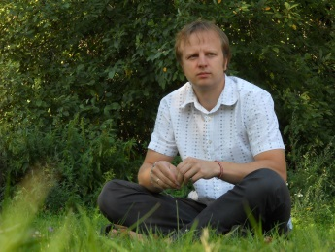
Siim Värv is working as quality manager for training activities for Estonian National Agency for Erasmus+: Youth in Action programme. His experience involves working in a school for young people with special needs as a school social worker, giving courses in Tartu University about non-formal education methodology and working as trainer in the field of non-formal education.

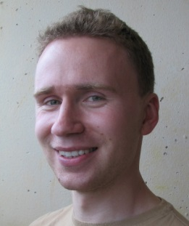
Uku Visnapuu provides trainings on social skills, teamwork and reflection in the youth sector since 1999. He has edited and published handbooks in youth field about self assessment, non-formal and informal learning. For his graduation theses he researched into the training needs of youth workers in Estonia.

Profile of participants: workers from youth work support structures, youth workers, youth work managers on the grass-root level and youth leaders with work experience in hobby education. You are especially welcome if you have experience in attempting to involve youth at risk or carry enthusiasm to do that in the near future.

We are inviting up to 20 persons from the above mentioned countries. It is essential that participants are fluent in English as the seminar relies heavily on in-depth conversations.

Detailed information package of the seminar will be sent to the selected participants.

-----------------
The seminar takes place in the frame of project HUKK-AP. The organizers will cover the program costs of the seminar, incl. accommodation and meals for all selected participants. The project HUKK-AP benefits from Erasmus+: Youth in Action programme and a grant from Iceland and Liechtenstein through the EEA Grants. The project aims to increase the systematic participation of young people at risk through quality youth work provision (especially through hobby education and recreation activities).

