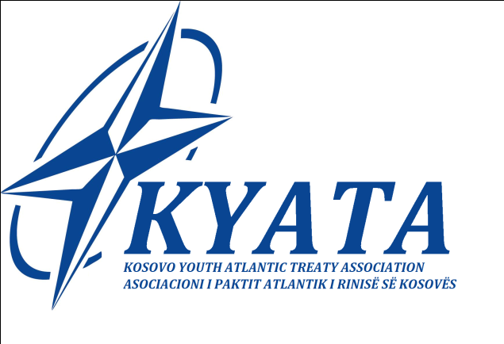
Kosovo Youth Atlantic Treaty Association has the pleasure to announce the first activity for 2015, on the honour of 7th Anniversary of Kosovo Independence:
“International Youth Conference on Security and Democracy in New Countries“ that is going to take place on 14 – 18 February 2015 at Kosovo Centre for Public Safety, Vushtri, Republic of Kosovo.
The objective of this Conference is to provide to participants a broad understanding on the historical development, the security, and the social and political dimensions of North Atlantic Treaty Organization, Kosovo Post-conflict State building process and impacts on the peace and stability of the region.
Furthermore, during this Conference will be provided a rich program with different academic and cultural activities such as:
- Guest speakers and lectures about Security, Role of Democracy in new countries, parliamentary oversight of security mechanisms and the role of parliamentary diplomacy for euro-atlantics integration,
- North Atlantic Council Simulation
- Visits in main cities of Kosova,(Peja, Gjakova and Prizren)
- Visits at historical places,
- Cultural nights
- KYATA Reception
Official language of the Conference will be English.
Target Group
Students with different academic backgrounds and a general interest in Euro-Atlantic integration will benefit from each other in an intercultural and interdisciplinary learning process. Youth leaders*politicians, interested students from Social Sciences or security studies, civil society, communication experts and others who may have interests on the event&topic.
Fee and Registration of participants:
Interested participants must send their CV and short Motivation letter before 9th of February 2015, and pay the fee via Bank.
Tuition fee:
Tuition fee for Kosovo students is 95 euro;
The tuition fee non Kosovo students is 110 euro
This tuition price includes:
- Accommodation, three meals per day (breakfast, lunch and dinner)
- All lectures, workshops, discussions (as mentioned in the program)
- Culture and social events (as mentioned in the program)
The only costs not included in the price are travel cost, and health insurance.

Scholarships:
KYATA is happy to inform that 4 scholarships are available for this conference
For more information and registration please contact us @:
E-mail:
info@yata-kosova.org
Mejreme.asllani@yata-kosova.org
kyata.info@gmail.com
Tel: +37745603619
www.yata-kosova.org
FB: Yata Kosova

